Deep learning homework 2  
ID: 0650736  
name: 邱奕中

1. i. Using PIL package to resize the image to 200 by 200.

ii.  
CNN_Net(

(conv1): Conv2d(3, 6, kernel_size=(3, 3), stride=(1, 1), padding=(1, 1))

(pool): MaxPool2d(kernel_size=2, stride=2, padding=0, dilation=1, ceil_mode=False)

(conv2): Conv2d(6, 16, kernel_size=(3, 3), stride=(1, 1), padding=(1, 1))

(conv3): Conv2d(16, 32, kernel_size=(3, 3), stride=(1, 1), padding=(1,1))

(fc1): Linear(in_features=20000, out_features=120, bias=True)

(fc2): Linear(in_features=120, out_features=84, bias=True)

(fc3): Linear(in_features=84, out_features=11, bias=True)

)

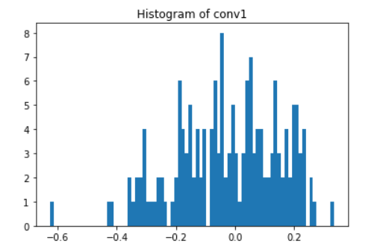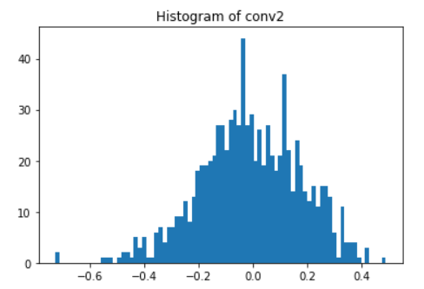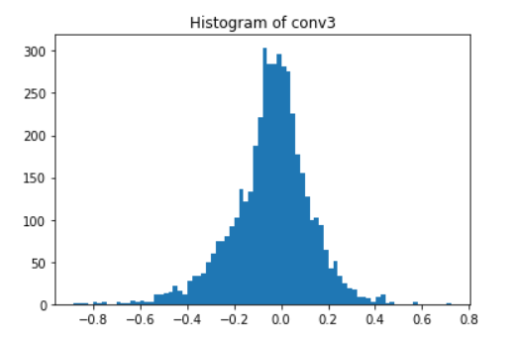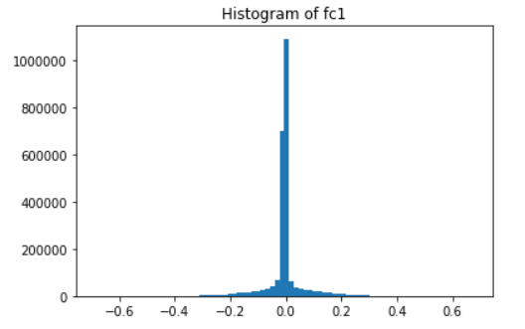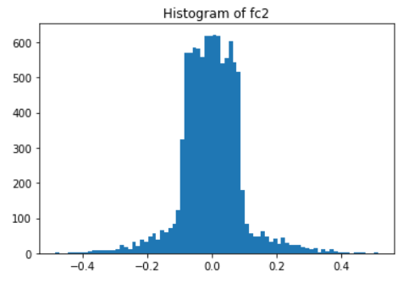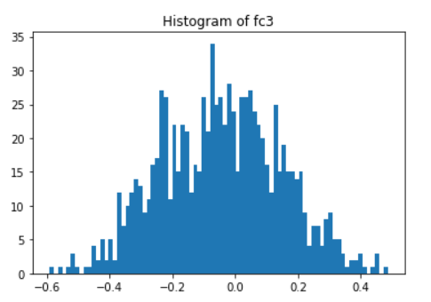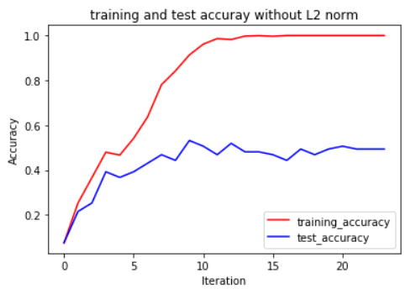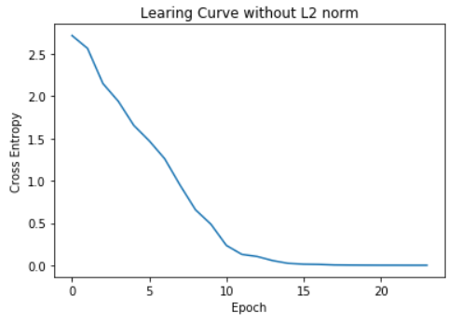

iii.

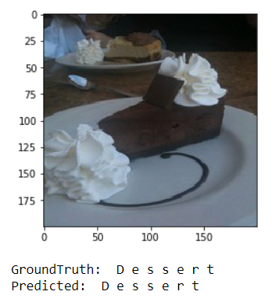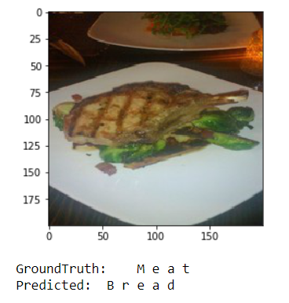  
iv.   
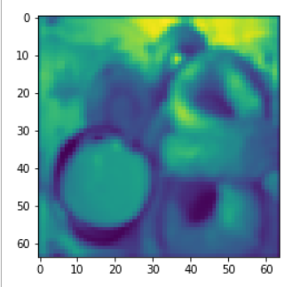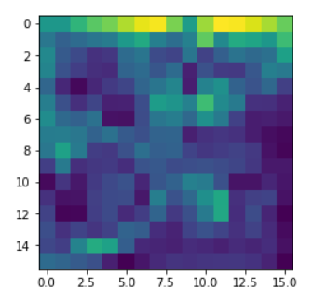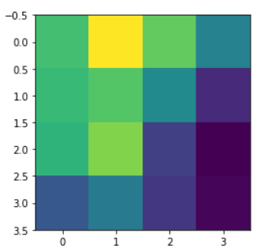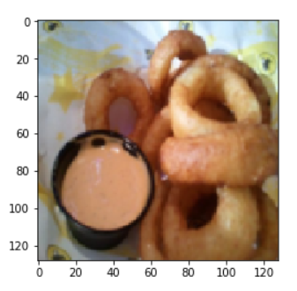  
v.  
 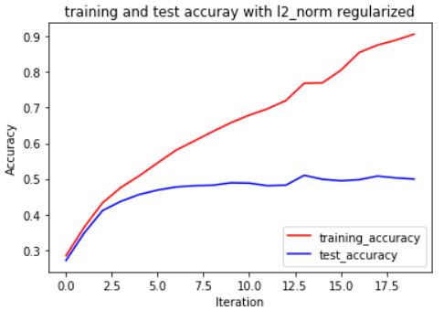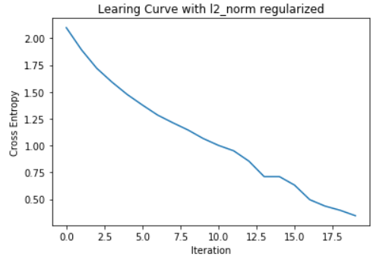

1. i. s = [N,C,T,U, ,i,s, ,g,o,o,d]  
    batch size = 2, sequence length=3  
    the output is [N,C,T], [U, ,i] for the first mini-batch.

ii. Architecture:   
 RNN(

(rnn): RNN(68, 256, batch_first=True)

(out): Linear(in_features=256, out_features=68, bias=True)  
)  
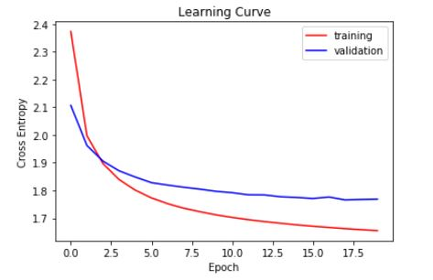

iii. Architecture:   
 RNN(

(rnn): LSTM(68, 256, batch_first=True)

(out): Linear(in_features=256, out_features=68, bias=True)  
)  
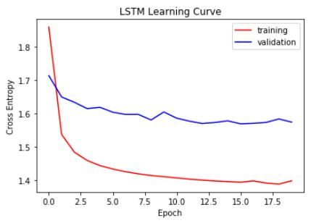

iv. Compared with RNN(cannot handle such “long-term dependencies”), LSTM can have more state information.